Yeek,
Just realized that we need one additional variable, namely the simulation month when the penalty search is first used, set in database to default value of 5*12=60 months so the penalty search won’t be used before about 5 years into ecospace simulations. Joe, maybe simple way to set this in code with just a warning to users that it won’t happen for the first several simulation years.
Carl
From: Jeroen Steenbeek <jeroen.steenbeek@gmail.com>
Sent: Saturday, January 21, 2023 1:54 PM
To: Joe Buszowski <joe@mountainsoft.net>; Christensen, Villy <v.christensen@oceans.ubc.ca>; Walters, Carl <c.walters@oceans.ubc.ca>
Subject: Re: New grid for penalty cost functions
Hi Joe,
The database fields are there, the new 4 variables save and load, and new UI is there too. I stuck it under Nav > Ecospace > Input > Ecospace fishery
I also registered the four new variables (cospaceFTarget, EcospaceDoPenaltysearch, EcospacePenpow and EcospaceNoFishWeight ) in cVariableMetaData.Init (EwECore\Core\cVariableMetaData.vb). Can you please check if the accepted value ranges are ok?
Jeroen
On 20-Jan-23 7:31 PM, Joe Buszowski wrote:
Hi Jeroen and Villy,
I’ve added a few of the basic penalty cost parameters to the Ecospace parameters dialogue. Jeroen, it would be great if you could add a group grid for the FTarget(group) to the Ecospace fisheries in the navigation panel. Unfortunately, we don’t have a group grid in fisheries yet so this will need to be a new dialogue. Also could you save the four variables below to the database.
- cEcospaceDataStructures.DoPenaltysearch Boolean turns it on or off.
- cEcospaceDataStructures.NoFishWeight weighting applied to attraction matrix and total effort in AdjustTotalEffort() Defaults to 0.3
- cEcospaceDataStructures.penpow power variable used to calculate the penalty cost. Defaults to 10.
- cEcospaceDataStructures.Ftarget(groups) target f for all groups. Defaults to 1000 which has no effect

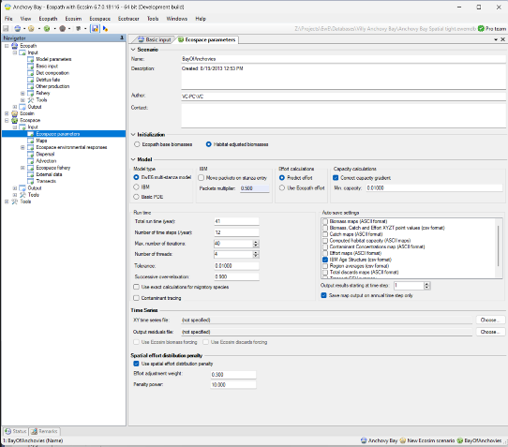
And earlier:

Hi Carl,

Here’s the email about the Ecospace penalty function that we discussed this morning

Best
Villy

On Nov 18, 2022, at 10:54, Walters, Carl <c.walters@oceans.ubc.ca> wrote:

Guys,
The linear programming approach that I suggested for finding optimum spatial fishing effort patterns will definitely not work, will give wildly chattering effort patterns over time. So will simple nonlinear optimization formulations. But it occurred to me that we may be able to have ecospace move over time to optimum patterns (constrained by total fishing rate bounds by group) by using a property of the nonlinear search procedures, namely they use a penalty function to keep efforts low enough to not violate fishing rate constraints, and move efforts up until the penalty value starts to increase. We can actually do this right in our spatial effort allocation subroutine (predicteffortdistributionthreaded), by adding a “cost” term for exceeding target exploitation rates to the denominator of the spatial attract values (attract) calculated for each fleet and cell. For each cell, this cost term will be of the form pencost-sum over groups of (m_Data.Bcell(i, j, isp) * m_SimData.relQ(ig, isp) * penpower * (Ftot(isp)/Ftarget(isp))^(penpower-1). Here, penpower is a fairly big value (10 or more), Ftot(ig) is the predicted total fishing rate on group g from the last time step, and Ftarget(ig) is the maximum allowable exploitation rate for group ig (setting this big causes the pencost to be near 0, ie. To ignore the Ftarget.

In order to implement this quite simple approach to using our gravity model to do the optimization, we first need to do two things: (1) set up a subroutine to be called inside but near the end of the findspatialequilibrium time loop, to calculate Ftot for the time step. FtotI(ig) is just the sum over all cells and fleets of Bcell(I,j,isp) * effort(I,j,ig), divided by the total over all I,j of Bcell(I,j,isp). And (2), we need to fix a “bug” in the spatial effort allocation that always forces ecospace to allocate total effort by gear ig to somewhere on the map, rather than having total effort drop off when there is nowhere good to fish. We can accomplish this second thing quite simply, by calculating the total effort allocation denominator as Ai/(sumAi +Anofish) so that there is an attraction weight IAnofish) for not fishing at all).

For point (2), we can calculate the Anofish(ig) quite simply in the AdjustTotalEFFort routine that gets called at t=3 in findspatialequilibrium. First, redimension global variable Anofish(Ig) to numfleets when findspatialequilibrium is called. Then in the AdjustTotalEffort routine, set Anofish(ig)=0.1*TotAttract just above the line that sets WtCat=0. Finally, multiply the TotEffort(ig) equation (last line before next ig) by 1.1 to correct base efforts upwards to account for the Anofish(ig) effect.

Given the Anofish(ig) values by fleet, simply change the line in PredictEffortDistributionthreaded that sets TotAttract = 0.0000001 to TotAttract = Anofish(iFlt) for all time steps and put calculation above of penalty cost into the loop for setting attract(I,j) for the fleet, for time steps after the optimization search is to be started (probably after about 5-10 years of simulation).

CJ

